Commitment Night 2021
Teams: C and D

Team Description:
C and D level teams are competitive teams which practice 1x per week and have set scrimmages throughout the season. These teams will learn to run basic offenses and defenses to prepare for competitive volleyball. As athletes, they will soon be able to play in any position, working through tough and unusual situations without letting it affect their play. Players will improve ball control and consistency on the court. Additionally, we emphasize positive team dynamics and sportsmanship throughout the season. Official teams for scrimmages will be determined after practices begin. These teams will be even regarding skill level and will be set based on player positions.

Coach Introductions and Expectations
- Coach Kat Maciejewski, C and D Team Lead Coach and Program Director
  - 404-667-7938
  - coachkat4@gmail.com
- Coach Calley Anderson, C and D assistant coach
  - calleyanderson9@gmail.com
- Additional Assistant coach TBD
All quick communications will be through Group Me. Reach out to your coach if you or another adult is not in the appropriate group. We have both player and parent groups.

Team Dynamics
Coaches will work with volunteers to ensure that all interested have a role. These are the primary roles available that we gathered interest for in the initial Commitment Night Form:
- Team Parent
  - Organizes team bonding events, Organizes who brings food to scrimmages (sign up genius), will help set up the end of season banquet alongside the Booster Club Liaison.
- Team Photographer/Videographer
  - Takes video and photographs of scrimmages, team bonding, and other events.
- Score Recorder
  - Takes note of the scores for all team scrimmages and reports them to the Public Relations Director to update social media (Twitter specifically).
- All other general parent volunteers will be an asset to help us chaperone events, take extra photographs, help set up and take down events, referee scrimmages, etc.
Fees and Fundraising
$150 for the season
Fees Include:
- Team T-Shirt
- Any additional gear related to specific events
- A reminder to all players that you must have your payments completed to receive your player packs. If you have not paid already, see us at the table before you leave.
Pay Fees Online:
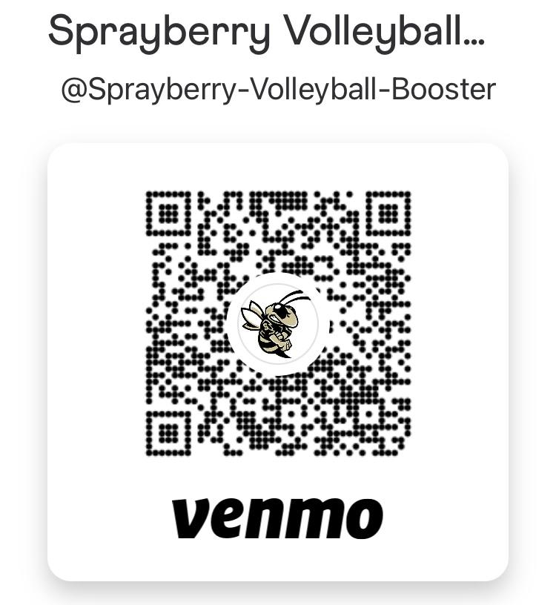 Square
Fundraising is still TBD at this time. We will send more information regarding fundraising as soon as our Middle School Fundraising Director has been solidified. If you have any ideas, please reach out to the coaches or in the GroupMe with your suggestion. Any help is welcome!

Schedule
Practices will be Fridays from 6:00-8:00pm
Scrimmages are listed below:
- Arrive to the first game at a location as soon as possible (up to an hour early if possible though we understand schools get out at difficult times for that to occur)
- Bring food. You cannot leave the school until after all the games are finished.
- Text or email your coach if you are missing ANY game or practice ahead of time. If they do not receive a notification, there will be a consequence. Simply keep us in the loop.
 | Location | Time
Saturday, August 28th | TBD | TBD (starts at 9am)
Tuesday, September 14th | Pope High School | 6:30 match  7:30 match
Friday, September 17th | Sprayberry High School | 6:30 match  7:30 match

Lil/Big Sis Hives
This is a new program this year that has the following goals:
- Increase community between high school and middle school players
- Create team bonding opportunities throughout the season
- Increase support at games and other major events

Organization:
- Each Hive (family) is made up of the following players:
  - 1 Varsity Player
  - 1 JV Player
  - 1 A Team
  - 1 B Team
  - 1 C or D Team
- Hives will range from 5-6 players from all levels of Sprayberry Volleyball

Events to look forward to:
- The first event is Saturday, August 21st from 3-5pm. These events are mandatory unless there is an unforeseen circumstance
  - When: Saturday, August 21st from 3-5pm
  - Where: Swift Cantrell Park
  - What: Team bonding activities and competitions between Hives
  - RSVP: https://www.signupgenius.com/go/10C0F4CA8A822A7FDC16-lilbig
- Future Hive Events:
  - Organized by the Booster Club secretary, Team Parents, and Middle School Community Improvement Director
  - If you are interested in joining the general volunteer pool for these events, join this group me: https://groupme.com/join_group/69631678/bV6bg4HN
- Future Game-Day Events
  - Juniors and High School players will both make goodie bags/posters at least once this season to support their Hive members
  - Recommended: Home Games

Full Schedule

August
Sun | Mon | Tues | Wed | Thurs | Fri | Sat
 |  | 3rd-Tryouts 6pm | 4th-Tryouts 6pm | 5th-Tryouts 6pm | 6th-Tryouts 6pm
 | 9th- Commitment Night 7pm |  |  |  | 13th- Practice 6:00-8:00pm
 |  |  |  |  | 20th- Practice 6:00-8:00pm | 21st- Lil/Big Sis First Hive Event 3:00-5:00pm
 | 23rd- Jv Home Game |  |  | 26th- JV Home Game | 27th- Practice/ Sprayberry scrimmages 6:00-8:00pm | 28th- C and D tournament
 |  |  |  |  | 3rd- Practice 6:00-8:00pm

September
Sun | Mon | Tues | Wed | Thurs | Fri | Sat
 |  |  | 8th- A and B Home Games |  | 10th- Practice 6:00-8:00pm
 |  | 14th- C and D Pope Scrimmage |  | 16th-  Varsity and JV Home Game | 17th- C and D’s Home Scrimmage
 |  |  |  | 23rd-  Senior Night | 24th- Practice/ Sprayberry scrimmage 6:00-8:00pm

